ROS2 nodes in docker

Retrieve the ROS docker image that has the tag "foxy-desktop."

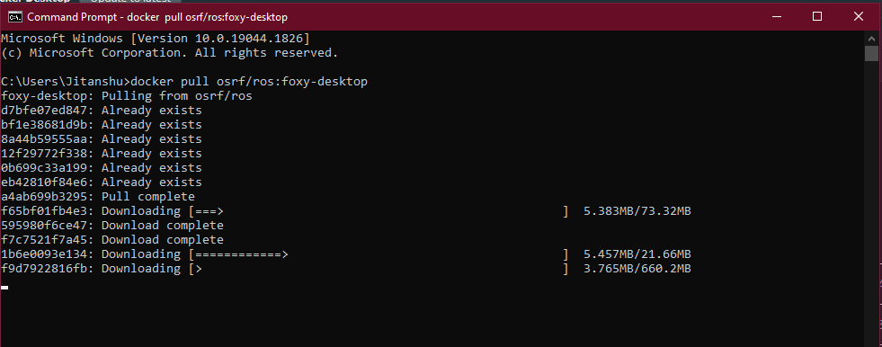

Run the image in a docker container using Terminal

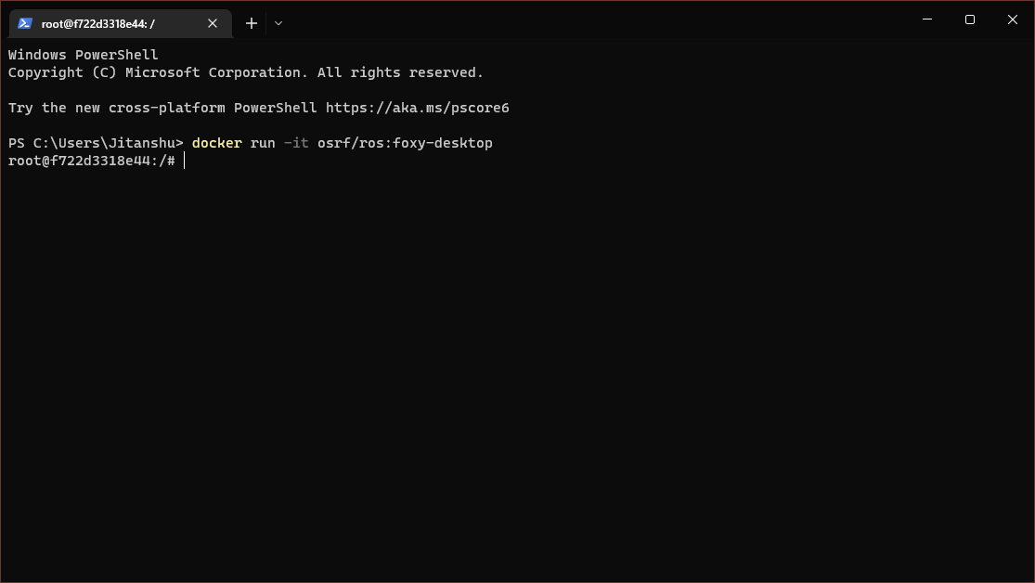

Now ros2 help command can provide you: -

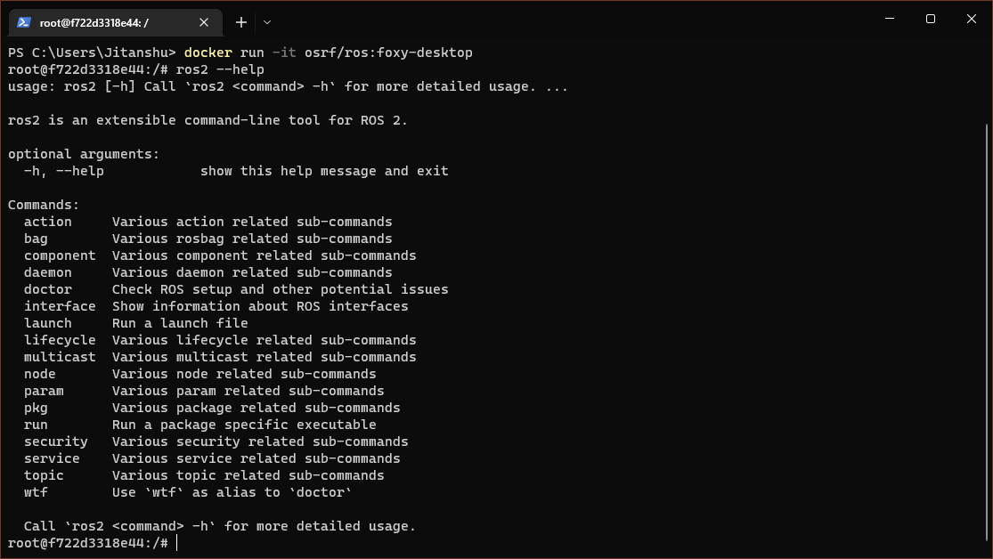

Running two separate docker container one for talker and other one for listener

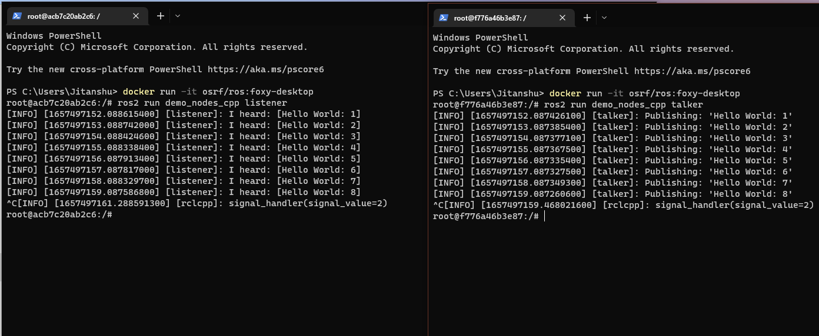

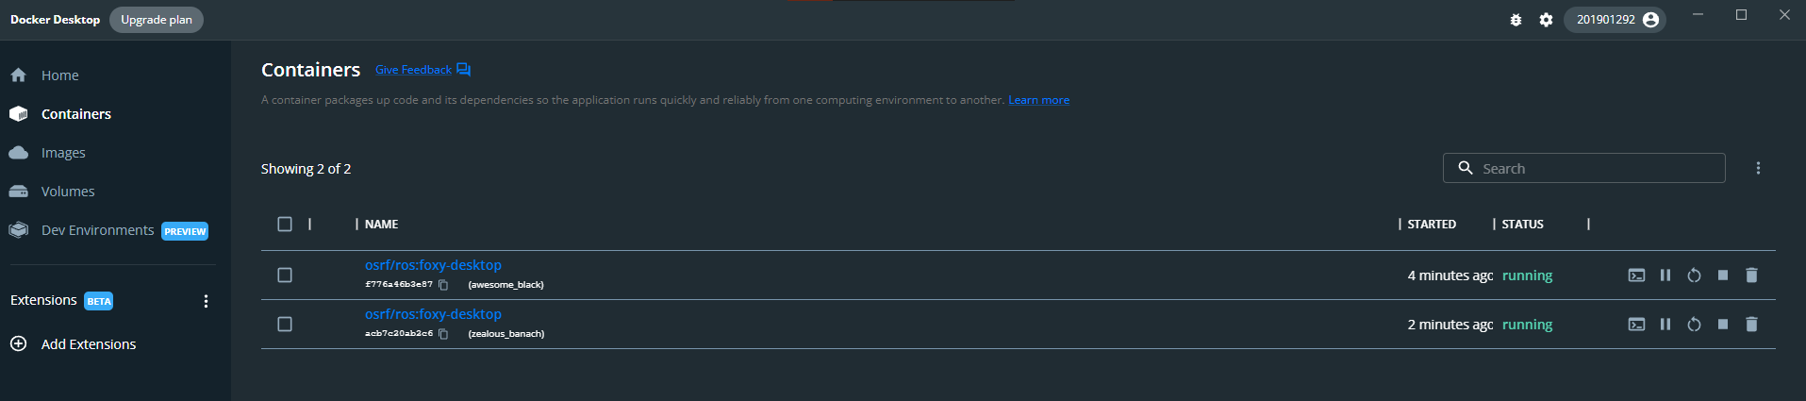

From the above image we can see that two different containers are running, one for the listener and the other for the talker.

Result

From the above demonstration, we can see that using Azure DevOps(docker) we can operate other devices connected to the Azure IoT hub In a similar way. The above demonstration shows the talker and listener using simulation, but can also be performed using two different devices using Azure IoT, which operates on the cloud. Also, there can be multiple devices connected at the same time. Basically, it is a broadcast sender and broadcast receiver, as we can have as many devices or nodes as listeners, or the other way, we can have as many talkers and one listener at the same time, and the device running smoothly.